Step 1: What is Image Annotation : <https://hackernoon.com/what-is-image-annotation-an-intro-to-5-image-annotation-services-yt6n3xfj?ref=hackernoon.com>

Step 2: CVAT Tutorial : [How to Label Images for Object Detection with CVAT](https://www.youtube.com/watch?v=OMgQ2JzOAWA)

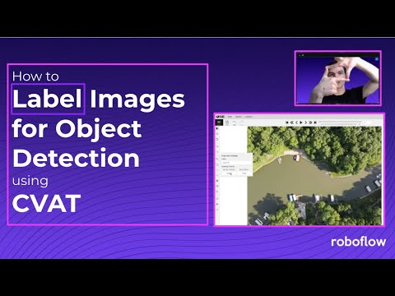

Step3: CVAT Tool : <https://cvat.org/auth/register> Register the CVAT with your email id

Step 4: Download Dataset : <https://wobotintelligence-my.sharepoint.com/:f:/g/personal/nithin_v_wobot_ai/Ev3XWcfS-fNHvQrgb2pHSRgBJ5RQH_N6yEL5aPlqlikxgg?e=Isbz2m>

Step 5 : Labels – Hand, Head, Person (you need to draw a rectangular box on the person , hand and head . overlapping of the boxes is not a problem

Step 6 : Export the annotations in the format : CVAT for images 1.1

Step 7 :Send the folder to wobot